void insertionSort(int arr[], int n)

{

int i, key, j;

for (i = 1; i < n; i++)

{

key = arr[i];

j = i-1;

/* Move elements of arr[0..i-1], that are greater than key, to one position

Ahead of their current position */

while (j >= 0 && arr[j] > key)

{

arr[j+1] = arr[j];

j = j-1;

}

arr[j+1] = key;

}

}

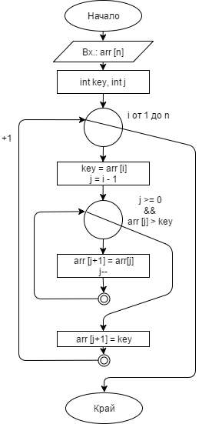

# С if & goto:

const int N = 5;

int arr[N] = { 31,34,12,22,11 };

int i = 1;

label1:

if (i < N)

{

//at is insert position

int at = i;

label2:

if (at > 0 && arr[at] < arr[at - 1])

{

//swap

int temp = arr[at];

arr[at] = arr[at - 1];

arr[at - 1] = temp;

at--;

i++;

goto label2;

}

else

{

i++;

goto label1;

}

}

for (int i = 0; i < N; i++)

{

cout << arr[i] << endl;

}